Week 10: Assessment Assignment
1Q) In the article "Data Quality Assurance with Best Practices," what are the best practices for ensuring data quality? Which one do you believe is most important and why?
Ans: Some of the strategies are elaborated in the article Data Quality Assurance with Best Practices to make data useful and credible. The best practices involve the construction of an enterprise data framework, keeping relevant, that is, maintaining accuracy and completeness, consistency, data up-to-date, and meeting security and legal requirements.
In my view these practices are necessary since they enable organizations to make superior, quicker and precise decisions. A framework of enterprise data proposes a systematic procedure of dealing with data on an intergroup basis, whereas relevance is the capability to confirm the data gathered to the interest of the company. Precision and fullness ensure that the information is accurate, realistic and reflective of the real values.
I believe that consistency in various systems will lead to the elimination of confusion and redundancy in reports, which will make them more reliable. Timeliness guarantees the up-to-date and updated information on which the decisions will be made. Compliance and security remove legal risks to organizations and keep customers trusting them. I think that the most important of all is accuracy and completeness, as no matter how good systems or models of AI can be cannot act well when they are not provided with the correct and complete data. Without precision, knowledge may be inaccurate, and judgments can result in expensive error.
In my opinion, greater attention paid to the accuracy of data allows enhancing analytics but also increases the credibility and effectiveness of an organization in the long term.
---------------------------------------------------------------------------------------------------------------------
2Q) In the article "Data cleaning: A Case Study with OpenRefine and Trifacta Wrangler," how do you produce high-quality datasets, according to the authors? Do you agree? Why or Why not?
Ans: The authors in the article Data Cleaning: A Case Study with open refine and trifacta wrangler define that to create high-quality datasets, data problems should be found and fixed by applying systematic data cleaning methods. They reiterate that data quality requires a number of dimensions including completeness, consistency, uniqueness, accuracy, validity and timeliness. The case study indicates that quality data is obtained by applying methods, such as the elimination of duplicates, missing values, outliers, structural errors, and format standardization. Such procedures are automated with the help of tools, such as OpenRefine and Trifacta Wrangler by clustering (applying Fingerprint, N-Gram Fingerprint and Phonetic Fingerprint methods) and data pattern validation.
In my opinion, the strategy is quite effective as it will involve both automation and human monitoring, which will guarantee cleaner and more correct data to analyze. I believe that the authors are correct in stating that data cleaning is the most time-consuming and, at the same time, the most important phase in any data science project.
I support this opinion since even excellent machine learning or data analysis models will not provide reliable results with untidied and validated data.
---------------------------------------------------------------------------------------------------------------------
3Q) In the article "10 Best data cleaning tools", where do many errors in data come from, according to the author? Identify another source of errors not provided by the author.
Ans: The article written by the author under the name 10 Best Data Cleaning Tools describes that most failures in data come as a result of a number of common causes throughout the data collection and processing processes. These consist of poor data entry, flaws in the source of data, source- destination system mismatch, and invalid calculations. In my opinion, these problems occur quite often since both human and computerized systems may introduce errors during the process of entry or transmission of information. As an illustration, a single typing mistake, i.e. typing in the wrong number, typing a misspelled name, etc., may lead to inconsistency across a database. Likewise, the importation of data in incompatible formats may cause it to give a mismatch or duplicate when data is imported in other sources that may not be of the same format.
I believe, even such minor technical problems as system crashes or upload failures can also corrupt data and result in incorrect analysis in the future. The author highlights that dirty data of this kind can adversely impact the organization by generating untrustworthy insights, rising operational expenses, and making bad business decisions. This indicates why data cleaning is a critical process before any form of modeling or analysis is done. I support the idea that the initial step to creating high-quality datasets is to find out the sources of data errors. Nonetheless, another significant source of data errors which is not described by the author, in my view, is old or obsolete data. In cases where organizations do not update their databases on a regular basis, then the information is stale and does not reflect the realities at the moment.
As an example, the address, contact numbers, or financial numbers of customers might change over time and utilization of obsolete data can mislead to incorrect conclusions. In my opinion, using obsolete data is a critical issue since it may confuse predictive models and corrupt business plans. Time inherently diminishes the data reliability even in the case when this data was accurate in the past. As such, it is equally significant to ensure that the data remains up to date, by monitoring and updating it, as it is to eliminate duplicates or correct erroneous records. I believe that such combination of good data entry habits and proper updating and auto validation will reduce errors to the greatest extent and will result in better organizational data in general. In so doing, businesses will be able to use their data to make accurate, informed and confident decisions.
---------------------------------------------------------------------------------------------------------------------
4Q) According to the article "OpenRefine: An Approachable Open Tool to Clean Research Data," what was the previous name of OpenRefine? Who supports OpenRefine today? Would you want to be a part of that team? Why or why not?
Ans: The authors in the article titled; OpenRefine: An Approachable Open Tool to Clean Research Data by Meg Miller and Natalie Vielfaure state that the tool was once referred to as Google Refine. Google ceased to support the project in 2012, but since that time, the project has been maintained and developed by a community of volunteers all around the world under the IaaS open-source platform on GitHub. I feel that this shift on a tool that is corporately backed to a community-oriented project is a sign of the power and the desire of the global open-source community. Such volunteers are still working on the software, creating new plugins, and offering support to their users via forums, documentation, and mailing lists. I believe it is also encouraging how OpenRefine has managed to develop even without the support of Google since it emphasizes the significance of collaboration and knowledge sharing in technology. The fact that it is free and maintained by volunteers all over the world goes to show how much one appreciates open, accessible, and privacy-respecting tools.
I think I would certainly want to join such a team since it is something that I am interested in regarding data science, open-source development, and enhancing the quality of data in others. Working on such a project would not just increase my technical abilities in cleaning the data and programming languages such as Java or Python, but also enable me to contribute to the academic and research community. In my opinion, it would be a wonderful and educative experience to work with a various set of developers and librarians that have one objective in common: to make research data tools better. In general, the success of the project OpenRefine as a community project demonstrates how collaboration can maintain innovation after the corporate sponsorship.

Hands-On
5Q) Download the latest version of OpenRefineLinks to an external site. and follow the directions to install it. Next, complete only the first 8 pages of the OpenRefine Tutorial Download OpenRefine Tutorial, and provide the two required screenshots. You will need to download two datasets: consumer_complaints Download consumer_complaints and earthquakes Download earthquakes.
- Project Created - Screenshot #1 of your Consumer Complaints Project with your initials
- Missing Zip codes - Screenshot #2 of your zip code missing count
Ans: #Screenshort1
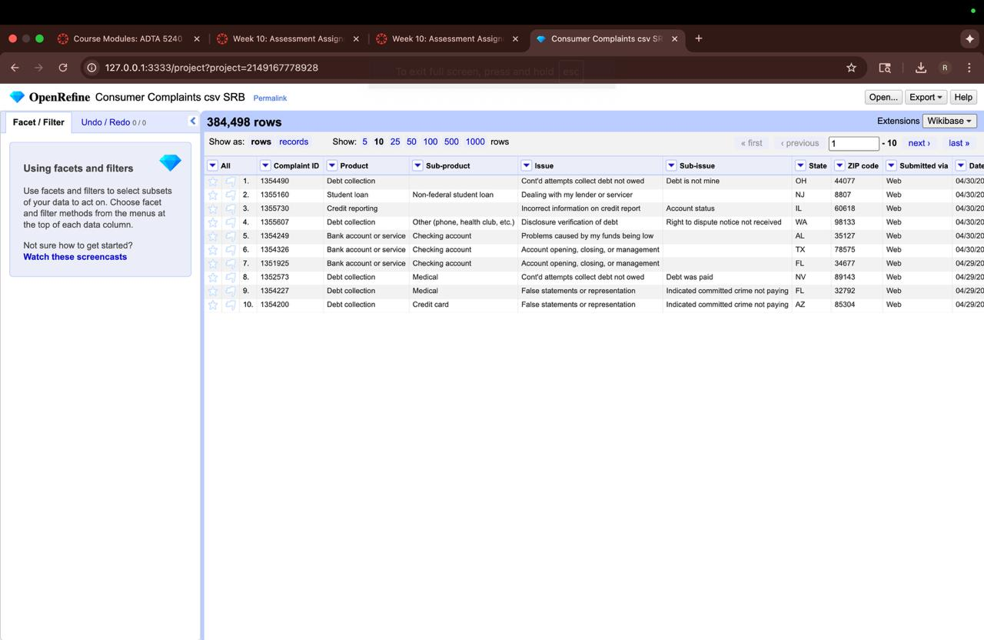

#Screenshort2
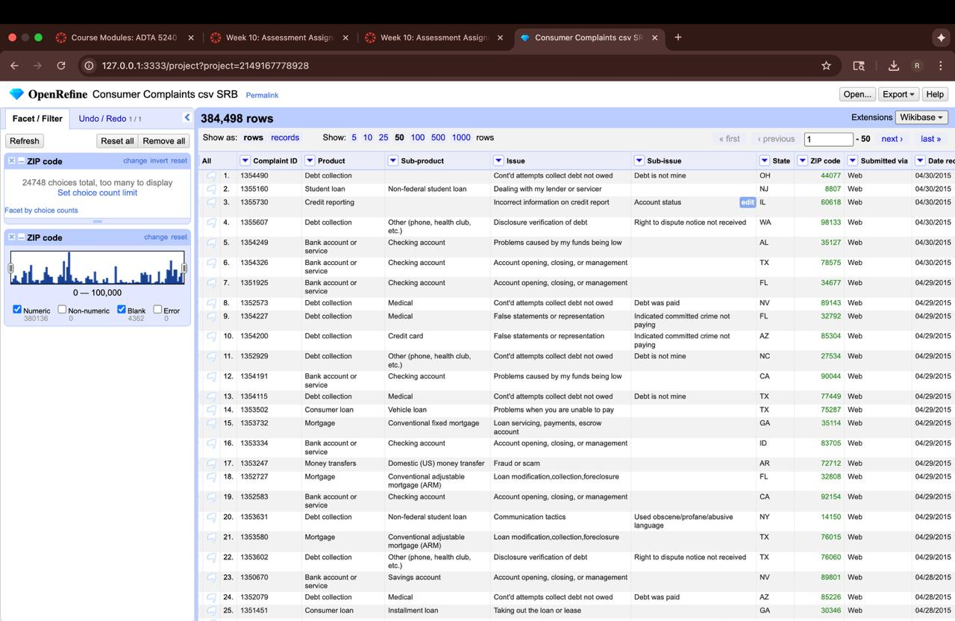

References:
- Dilmegani, C. (2025, July 3). Data Quality Assurance with Best Practices. AI Multiple. Retrieved from https://research.aimultiple.com/data-quality-assurance/ AIMultiple
- Petrova-Antonova, D., & Tancheva, R. (2020, September). Data cleaning: A case study with OpenRefine and Trifacta Wrangler. In M. Shepperd, F. Brito e Abreu, A. Rodrigues da Silva, & R. Pérez-Castillo (Eds.), Quality of Information and Communications Technology: QUATIC 2020 (Comm. in Computer & Info. Sci., Vol. 1266, pp. 32-40). Springer, Cham. https://doi.org/10.1007/978-3-030-58793-2_3 gate-ai.eu+1
- McFarland, A. (2022). 10 Best data cleaning tools. United AI. [If possible include URL]
- Miller, M., & Vielfaure, N. (2022, March 23). OpenRefine: An approachable open tool to clean research data. Bulletin – Association of Canadian Map Libraries and Archives (ACMLA), (170). https://doi.org/10.15353/acmla.n170.4873 Waterloo Open Journals
- Hands-On Tutorial for OpenRefine. (n.d.). In OpenRefine Tutorial (first 8 pages). Retrieved from the OpenRefine website.

